Positive Puberty Plus Programme
Fill in the blanks:
Puberty means ……………………………………………………… and your ‘child’ body is growing into an ‘………………….’ body capable of ………………………………..
Your body changes because of the effects of ……………………………………
The main hormones causing changes in girls are …………………………………………….. and
………………………………………. The female reproductive cell, contained in the ovary, is called the …………………
The main hormone causing changes in boys is called …………………………………………………
The male reproductive cell, produced in the testicles, is called the ………………
As well as making lots of physical changes such as: ………………… …………., ……………
……..……. …….., ………… ………….… ………..., ……………………, ……………….. ……………,
…………….. ……………………… hormones also affect ………………………………………………………
……………………………………………………………………………………………………………………………………
Oestrogen … There are changes ahead!...Reproduction…Hairs growing … Getting taller…Body shape changing…Sweating more… Skin getting oily…Voice deepening … Egg or Ova … Progesterone … Hormones … The way we feel and think … Testosterone … Sperm…Adult
I think going through puberty is
……………………………………………………………………………………………………………………………………
Because …………………………………………………………………………………………………………………………………..
……………………………………………………………………………………………………………………………………
A good thing about puberty is
……………………………………………………………………………………………………………………………………
In what ways could you and your friends support each other as you go through puberty?
……………………………………………………………………………………………………………………………………
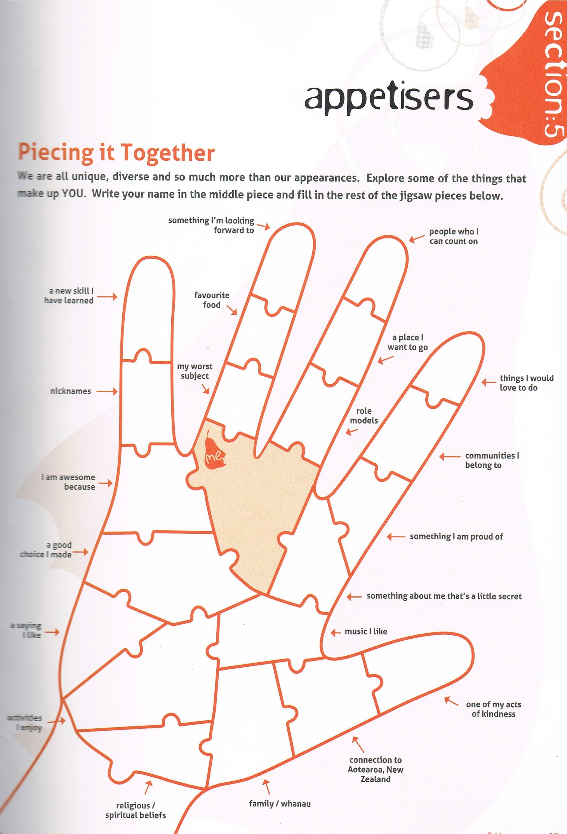
Love Your Body!
We are all different so enjoy being you!

